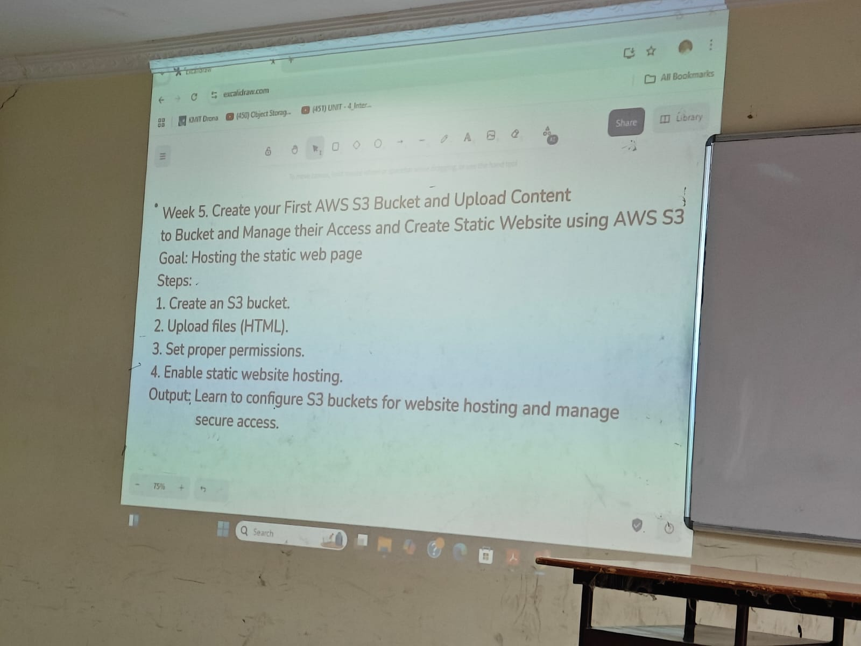

1) Create a S3 Bucket , enable ACLs

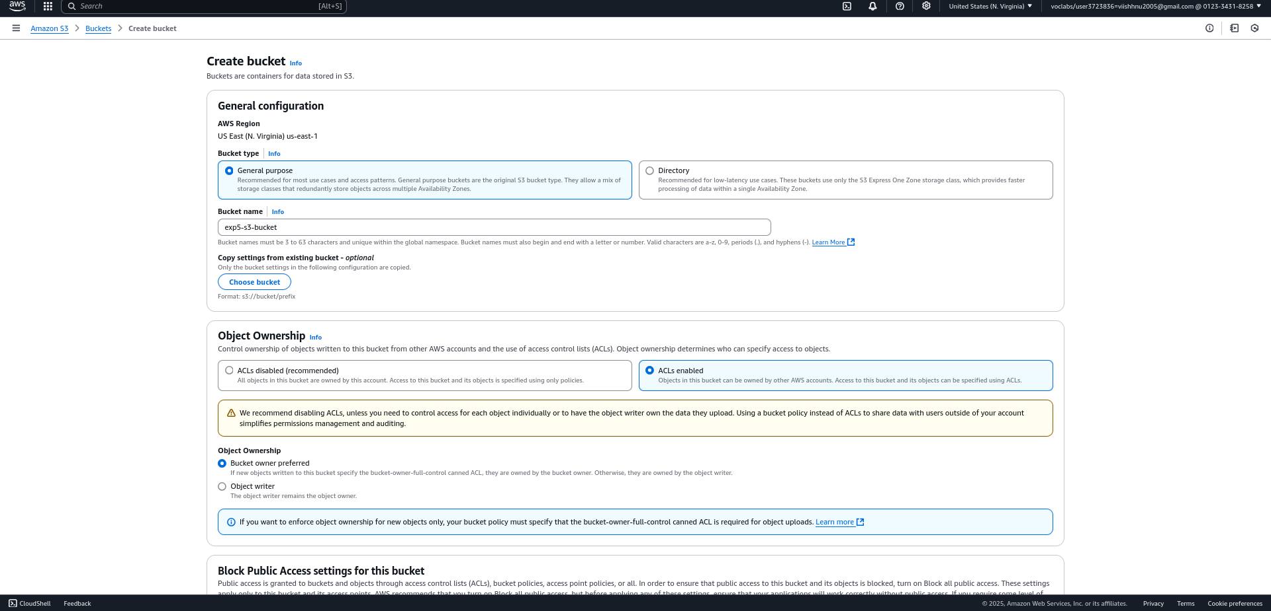

2) Now un check the box of block public access

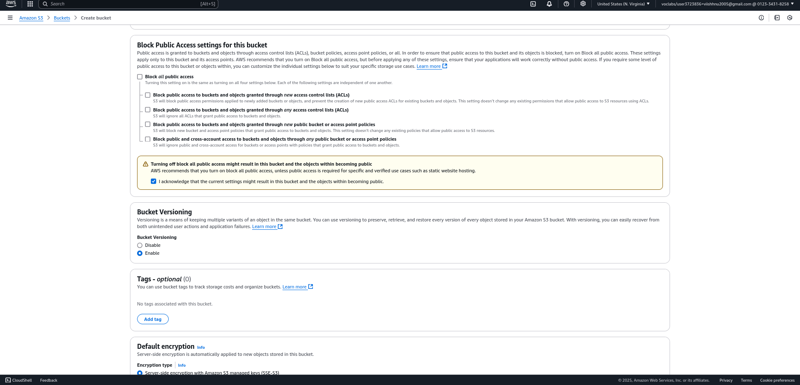

3) Now the bucket has been created succesfully

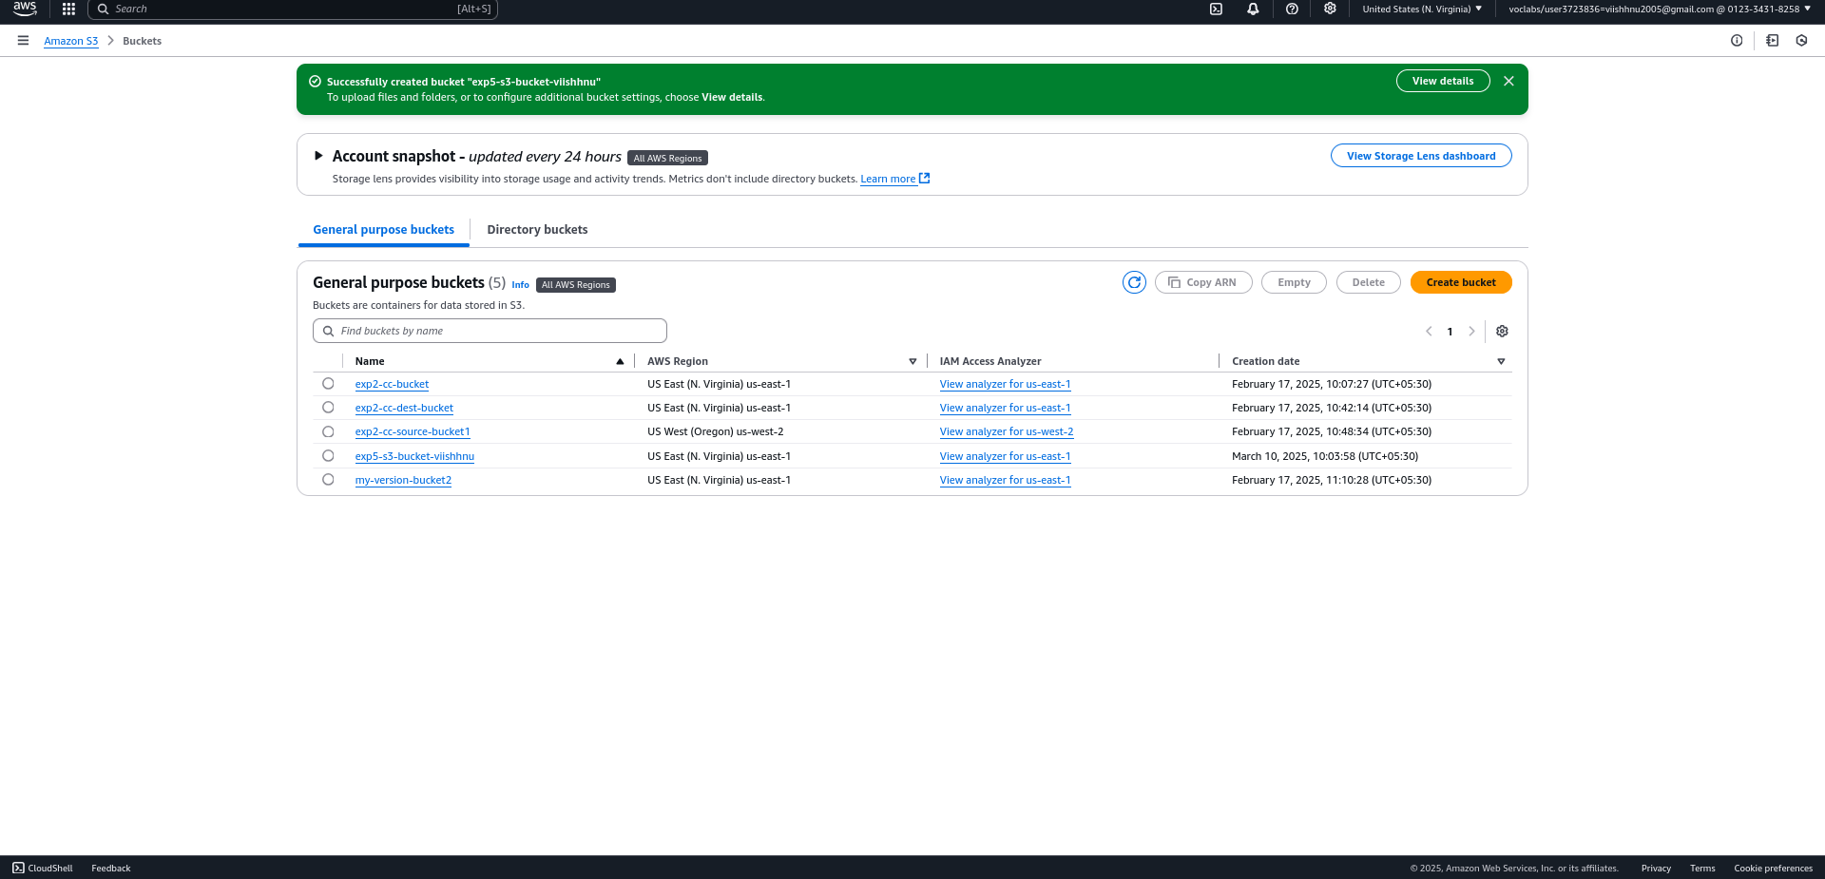

4) Upload the index.html file

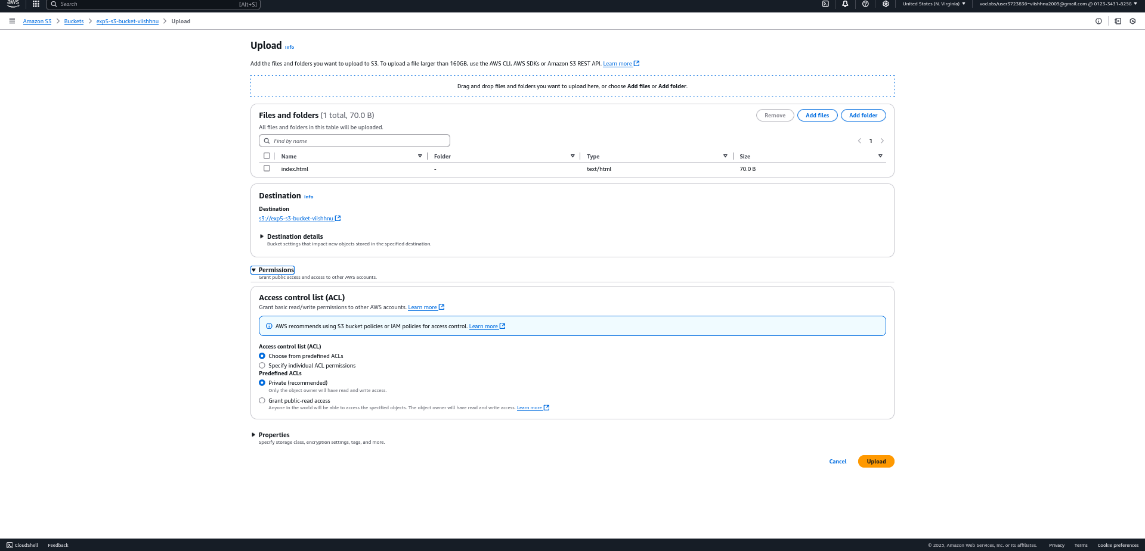

5) Now the static index.html is uploaded successfully

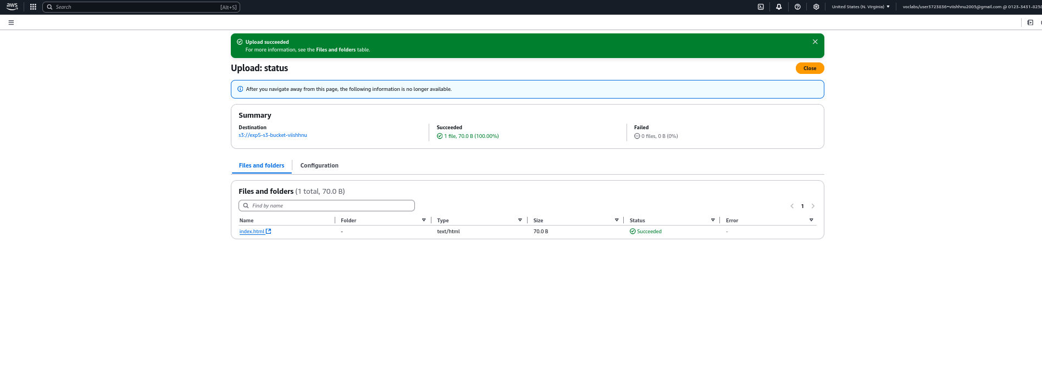

6) Edit Object level permissions

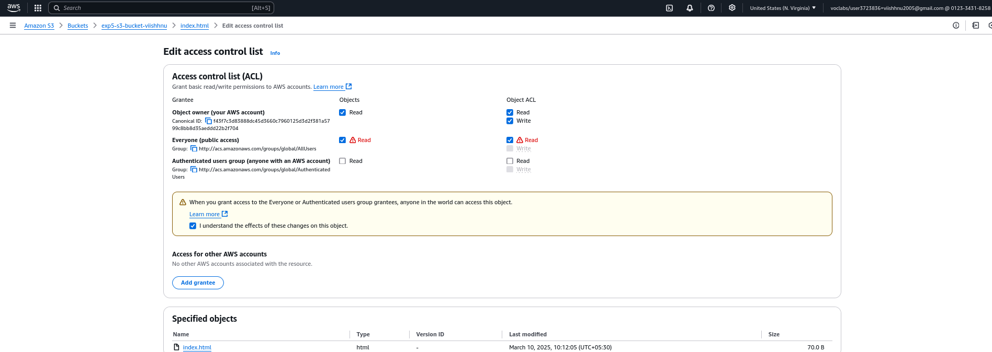

7) Enable Static website hosting

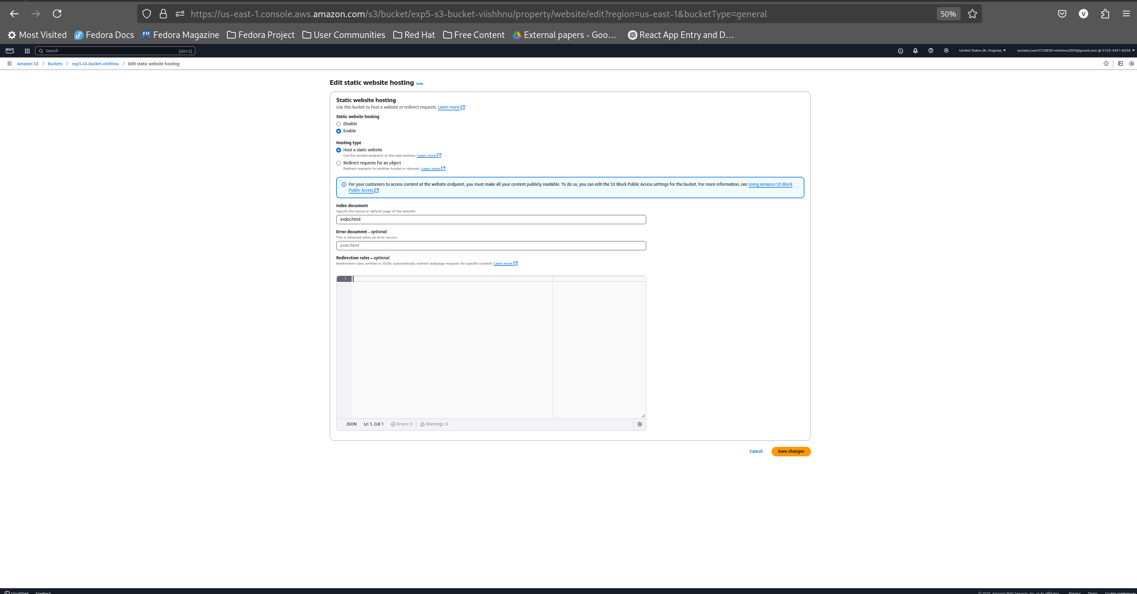

8) Now access the static website using the **url(http://exp5-s3-bucket-viishhnu.s3-website-us-east-1.amazonaws.com/)**

